Employee payroll management

Project Team no: | 02
Project Name: | Employee payroll management

Table of Contents

- INTODUCTION
- SYSTEM OVERVIEW
- SUB-SYSTEM DETAILS
- DATA ORGANIZATION
- REST APIs to be Built
- ASSUMPTIONS
- EXPECTATIONS
- ACCEPTANCE CRITERIA
- OUTPUT SCREENSHOTS
10.CONCLUSION

- Introduction

XYZ Ltd is a company which builds a software system which is responsible for Employee payroll management of employees.

XYZ Ltd plans to develop “Employee payroll management” – web application, where Admin can register, login, add employees, add employees for payment etc. and Employee can register, login, see their profile, payslip etc.

Abstract:

“Employee Payroll Management” is designed to make the existing manual system automatic with the help of computerised equipment and full-edged computer software, fulfilling their requirements, so that their valuable data and information can be stored for a longer period with easy access and manipulation of the same. The required software is easily available and easy to work with. This web application can maintain and view computerised records without getting redundant entries. The project describes how to manage user data for good performance and provide better services for the client.

Background of the project:

Employee payroll management is an internet-based Java application that automates the working of a company or work center that manage and maintain records of the employees in different department. The objective of the Employee payroll management project is to design a scheduling system for a work center. Scheduling is such a tool with which the process of intimating activities and notifications will be easy and even online in the organization where it is installed. But these tasks of scheduling the different activities if manually done whether they may be personal, or official is time consuming and may lead to confusion if not properly scheduled. The supervisor holds the various activities like sending notifications, mark attendance, and deleting the employees, and on the other hand employees view their details, view schedule or the notifications or any message from supervisor, and view attendance.

Scope and Overview:
The scope of the “Employee payroll management” will be provide the functionality as declared below. The system will be developed on a windows operating system using Java/J2EE, Hibernate, Angular, Spring Boot, MySQL.

2 System overview
The “Employee payroll management” should support basic functionalities for all below listed users.
- Admin
- Employee
2.1 Authentication & Authorization
Authentication:
Any employee should be authenticated using a unique emailed and password.
Authorization
The operations supported and allowed would be based on the user type. For example, Admin has the rights to add Employee and add Payment.
Whereas Employee has right to view their profile and payslip.
Password Rules:
When it comes to password safety, the longer and more complex the password is, the better. We think its good practice to enforce certain minimum requirements when asking users to create a new password. Of course, you have to find a balance between these requirements and user experience. If you make the sign-up process too tedious, you could be driving users away. To enforce password strength, you should define a set of rules that a password must satisfy and then enforce these with form validation. Example password strength rules:
• Minimum of 8 characters
• At least one uppercase letter
• At least one number
• At least one special character
2.2 Requirement Specification:
. To be used efficiently, all computer software needs certain hardware components or the other software resources to be present on a computer. These pre-requisites are known as(computer) system requirements and are often used as a guideline as opposed to an absolute rule. Most software defines two sets of system requirements: minimum and recommended. With increasing demand for higher processing power and resources in newer versions of software, system requirements tend to increase over time. Industry analysts suggest that this trend plays a bigger part in driving upgrades to existing computer systems than technological advancements.

HARDWARE REQUIREMENTS:
The most common set of requirements defined by any operating system or software application is the physical computer resources, also known as hardware. A hardware requirements list is often accompanied by a hardware compatibility list (HCL), especially in case of operating systems. An HCL lists tested, compatibility and sometimes incompatible hardware devices for a particular operating system or application. The following sub-sections discuss the various aspects of hardware requirements.
HARDWARE REQUIREMENTS FOR PRESENT PROJECT:
PROCESSOR: Intel dual Core, i3
RAM: 1 GB
HARD DISK: 80 GB
SOFTWARE REQUIREMENTS:
Software Requirements deal with defining software resource requirements and pre-requisites that need to be installed on a computer to provide optimal functioning of an application. These requirements or pre-requisites are generally not included in the software installation package and need to be installed separately before the software is installed.
SOFTWARE REQUIREMENTS FOR PRESENT PROJECT:
OPERATING SYSTEM: Windows 10
FRONT END: Html, CSS, java script. (Angular)
BACK END: STS (Spring Tool Suite)
SERVER-SIDE SCRIPT: Apache tomcat 8
DATABASE: MySQL
TESTING: Junit and Postman
Assumptions and Dependencies:
Assumptions:
• The code should be free with compilation errors/syntax errors.
• The product must have an interface which is simple enough to understand.
Dependencies:
• All necessary hardware and software are available for implementing and use of the tool.
• The proposed system would be designed, developed and implemented based on the software requirements specifications document.
• End users should have basic knowledge of computer and we also assure that the users will be given software training documentation and reference material.
• The system is not required to save generated reports.

2.4 Schematic Diagram:

START
ADMIN
ADD EMP
ADD PAYMENT
ADD WORK
ADD ATTENDENCE
PROFILE
VIEW PAYSLIP
VIEW ATTENDENCE
ADD TIMESHEET
VIEW TIMESHEET
EMPLOYEE
LOGOUT
VIEW SCHEDULE
REGISTER
NO
LOGIN
LOGIN

NO

2.5 Employee payroll management Database

ID
EMAIL_ID
Password
USER_NAME
USER_NAME
PASSWORD
EMP_ID
CITY
DESIGNATION
DOB
EMAIL_ID
F_NAME
GENDER
L_NAME
LOCATION
MOB_NO
PASSWORD
PINCODE
STATE
STREET

USER _NAME
PASSWORD

ADMIN REGISTER
ADMIN LOGIN
EMPLOYEE REGISTER
EMPLOYEE LOGIN
BASIC_PAY
DA
DEDUCTION
EMP_ID
GROSS_SALARY
HRS
NET_PAY
PF_AMOUNT
TAX
TRAN_DATW

ADD PAYMENT
DURACTION
END_DATE
LEAVE_TYPE
START_DATE
ADD LEAVE
BREAK_TIME
DATE
IN_TIME
OUT_TIME
OVERTIME_HOURS
REGULAR_TIME
TOTAL_HOURS

ADD TIMESHEET
DATE
STATUS
ADD ATTENDENCE

Admin registration table:
Column | Datatype | Length
Id | Int
Email_id | Varchar | 255
Password | Varchar | 255
User_name | varchar | 255

Employee registration table:
Column | Datatype | Length
Emp_id | Int
City | Varchar | 255
Designation | Varchar | 255
Dob | Varchar | 255
Email_id | Varchar | 255
F_name | Varchar | 255
Gender | Varchar | 255
L_name | Varchar | 255
Location | Varchar | 255
Mob_no | Varchar | 255
Password | Varchar | 255
Pincode | Int
State | Varchar | 255
Street | Varchar | 255

Admin Login:
Column | Datatype | Length
Email_id | Varchar | 255
Password | Varchar | 255

Employee Login:
Column | Datatype | Length
Email_id | Varchar | 255
Password | Varchar | 255

Salary table:
Column | Datatype | Length
Sal_id | Int
Basic_pay | Double
Da | Double
Deduction | Double
Emp_id | Int
Gross_salary | Double
Hra | Double
Net_pay | Double
Pf_amount | Double
Tax | Double
Tran_date | Varchar | 255

Timesheet table:
column | Datatype | Length
Emp_id | Int
Break_time | Varchar | 255
Date | Varchar | 255
In_time | Varchar | 255
Out_time | Varchar | 255
Overtime_hours | Varchar | 255
Regular_time | Varchar | 255
Total_hours | Varchar | 255

Attendance table:
Column | Datatype | Length
Emp_id | Int
Date | Varchar | 255
Status | Varchar | 255

Leaves table:
Column | Datatype | Length
Emp_id | Int
Duration | Varchar | 255
End_date | Varchar | 255
Leave_type | Varchar | 255
Start_date | Varchar | 255

Work Schedule table:
Column | Datatype | Length
Emp_id | Int
Date | Varchar | 255
Shift | Varchar | 255
Strat_time | Varchar | 255
End_time | Varchar | 255
Duration | Varchar | 255

case diagram:
case diagram is a visual representation of how a user might interact with a program. A use case diagram depicts the system’s numerous use cases and different sorts of users. The circles or ellipses are used to depict the use cases.
MANAGING EMPLOYEE
MANAGING PAYMENT
MANAGING TIMESHEET

Employee
ADMIN

MANAGING SCHEDULE

3 Sub-System Details
The Employee payroll management is defined, where in all employees need to login successfully before performing any of their respective operations. Below tables that provides functionality descriptions for each type of user. Against each requirement, indicative data is listed in column ‘Data to include’.

Admin
The admin as a user is defined to perform below listed operations after once admin login.
Objects | Operations | Data to include | Remarks
User | register | Id,Email_id,User_name,Password
Employee list | view | Emp_id,Email_id,Designation,F_name,L_name,Mob_no,gender..
Payment | generate | Sal_id,Basicpay,Deduction,Emp_id,Gross_sal,Net_pay
Work schedule | add | Emp_id

Employee
The Employee as a user is defined to perform below listed operations after once employee login.
Objects | Operations | Data to include | Remarks
User | register | Id,Email_id,User_name,Password,Designtion  Mob_no,gender..
Profile | view | Emp_id,Email_id,Designation,F_name,L_name,Mob_no,gender,password..
Payslip | view | Sal_id,Basicpay,Deduction,Emp_id,Gross_sal,Net_pay,date_Trans..
Work schedule | view | Emp_id

4 Data Organization
This section explains the data storage requirements of the Employee payroll System and indicative data description along with suggested table (database) structure. The following section explains few of the tables (fields) with description. However, in similar approach need to be considered for all other tables.

Admin Registration table
Field name | Description
Admin_id | Id is autogenerated after Registration
User_name | Name of the admin
Email_id | Email of the admin
Password | Admin unique password

Employee Registration table
Field name | Description
Emp_id | Id is autogenerated
Email_id | Email of the employee
Password | Employee unique password
F_name | Employee first name
L_name | Employee last name
Mob_no | 10 digit employee mobile number
Gender | Give gender weather male/female
Address | Address of the employee
Designation | Designation of employee

Payment table
Field name | Description
Sal_id | Id is autogenerated
Basic_pay | The total basic salary
Deduction | Deduction in salary
Emp_id | Employee id
Gross_salary | Monthly salary
Hra | Hr allowances
Net_pay | In hand Total salary
Tran_date | Date of transaction

Time Sheet table
Field name | Description
Emp_id | Employee id
Date | Particular date
Regular_time | Regular working hours
Overtime_hours | Over time done by employee
Total_hours | Total hours work done

Attendance table
Field name | Description
Emp_id | Employee id
Date | The attendance date
Status | Weather employee present/absent

Leaves table
Field name | Description
Emp_id | Employee id
Duration | How many leave days
Start_date | Starting date of leave
End_date | Ending date of leave
Leave_type | Type of leave the employee taking

Work Schedule table
Field name | Description
Emp_id | Employee id
Date | Date of work schedule
Shift | Shift of work
Start_time | Start time of work
End_time | End time of work
Duration | Duration of work

5 REST APIs to be Built
Create following Rest resources which are required in the application

- Creating Admin Entity: Create Spring Boot Application with Spring Data JPA
Technology stack:
- Spring Boot
- Spring REST
- Spring Data JPA
Here we have multiple layers into the application:
- Create an Entity: Admin
- Create a AdminRegistrationRepository interface and will make use of Spring data JPA
- Will have findByEmailId method.
- Will have findAdmByEmailIdandPassword
- Add admin details
- Create AdminRegistrationService class and will expose all these services
- Finally, create Admin AdminRegistrationController will have the following Uri’s
POST
http://localhost:8085/api/v1/registeradm
http://localhost:8085/api/v1/login
- Create a AdminRepository interface and will make use of Spring data JPA
- will have createEmployee methode
- will have findById
- Finally, create Admin AdminController will have the following Uri’s
GET
http://localhost:8085/admin
http://localhost:8085/{empId}
POST
http://localhost:8085/{empId}
DELETE
http://localhost:8085/admin

- Create an Entity: Employee
- Create a EmpRepository interface and will make use of Spring data JPA
a) Will have findById methode.
- Create RegistrationService class and will expose all these services
- Finally, create EmpController will have the following Uri’s
GET
http://localhost:8085/api/v2/ {empId}
PUT
http://localhost:8085/api/v2/employee/{emailId}

- Create an Entity: Employee
- Create a EmpRepository interface and will make use of Spring data JPA
a) Will have findById methode.
- Finally, create RegistrationController will have the following Uri’s
POST
http://localhost:8085/registeremp
http://localhost:8085/emplogin
PUT
http://localhost:8085/forgotpasswordemp

- Create an Entity: Attendance
- Create a AttendanceRepository interface and will make use of Spring data JPA
a) Will have findById methode.
- Finally, create EmpController will have the following Uri’s
GET
http://localhost:8085/api/v3/{empId}
http://localhost:8085/api/v3/employees
POST
http://localhost:8085/api/v3/employee/employees
DELETE
http://localhost:8085/api/v3/employee/ {empId}

- Create an Entity: Leave
- Create a LeaveRepositoryinterface and will make use of Spring data JPA
- Will have findById methode.
- Will have findAll methode
- Finally, create EmpController will have the following Uri’s
GET
http://localhost:8085/api/v4/ {empId}
http://localhost:8085/api/v4/leaves
POST
http://localhost:8085/api/v4/leaves
DELETE
http://localhost:8085/api/v4/employee/ leaves/{empId}

- Create an Entity: Salary
- Create a SalaryRepository and will make use of Spring data JPA
- Will have findById methode.
- Will have fetchSalaryList methode
- Will have saveSalary methode
- Will have fetchSalaryById methode
- Will have deleteSalById methode
- Create SalaryServices service
- Finally, create SalaryController will have the following Uri’s
GET
http://localhost:8085/api/v7/{empId}
http://localhost:8085/api/v7/getsalary
http://localhost:8085/api/v7/getsalarybyid/{id}
POST
http://localhost:8085/api/v7/addsalary
http://localhost:8085/api/v7/editsalary
DELETE
http://localhost:8085/api/v7/deletesalary/{empId}
- Create an Entity: Schedule
- Create a ScheduleRepository and will make use of Spring data JPA
- Will have findById methode.
- Will have findAll methode
- Finally, create ScheduleController will have the following Uri’s
GET
http://localhost:8085/ /api/v6/schedule
http://localhost:8085/ api/v6/{empId}
POST
http://localhost:8085/ api/v6/schedule
PUT
http://localhost:8085/ api/v6/schedule/{empId}

DELETE
http://localhost:8085/api/v6// schedule/{empId}

- Create an Entity: Timesheet
- Create a TimesheetRepository and will make use of Spring data JPA
- Will have findById methode.
- Will have findAll methode
- Finally, create TimesheetController will have the following Uri’s
GET
http://localhost:8085/api/v5/{empId}
http://localhost:8085/ api/v5/timesheets
http://localhost:8085/ api/v5/timesheets/{emplId}

POST
http://localhost:8085/ api/v5/timesheets
PUT
http://localhost:8085/ api/v5/timesheets/{empId}

DELETE
http://localhost:8085/api/v5/timesheets/{empId}

6 Assumptions
●Each user (Admin, Employee) must have a valid user id and password
●Server must be running for the system to function
●Users must log in to the system to access any record.
●Only the Administrator can delete records
7 General Expectations
- Participants must create the Class Diagram, Sequence Diagram and ER Diagram.
- Participants must do Unit testing and Functional Testing using POSTMAN tool.
- Integration of Angular and Spring Boot with Microservices should be done, referring Project 2 -Frond End Development Project.
- The server should be a concurrent server servicing multiple clients.
- Database can be implemented using MySQL.
- To begin with, the application should support at least 1 admin.
- Compilation and Build should be done using Eclipse IDE or STS
- Source-code and all documents must be maintained (checked-in) in configuration management system (subversion)
- Coding standards (for Java) should be followed.
8 Acceptance Criteria
All P1 requirements must be mandatorily implemented.

9 Output Screenshots
Homepage:
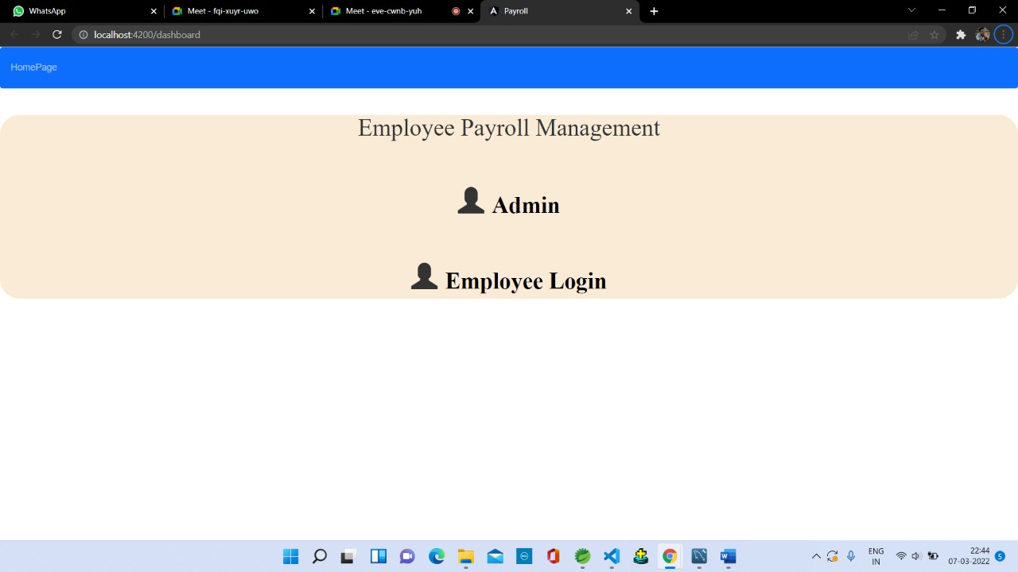

Admin Login:
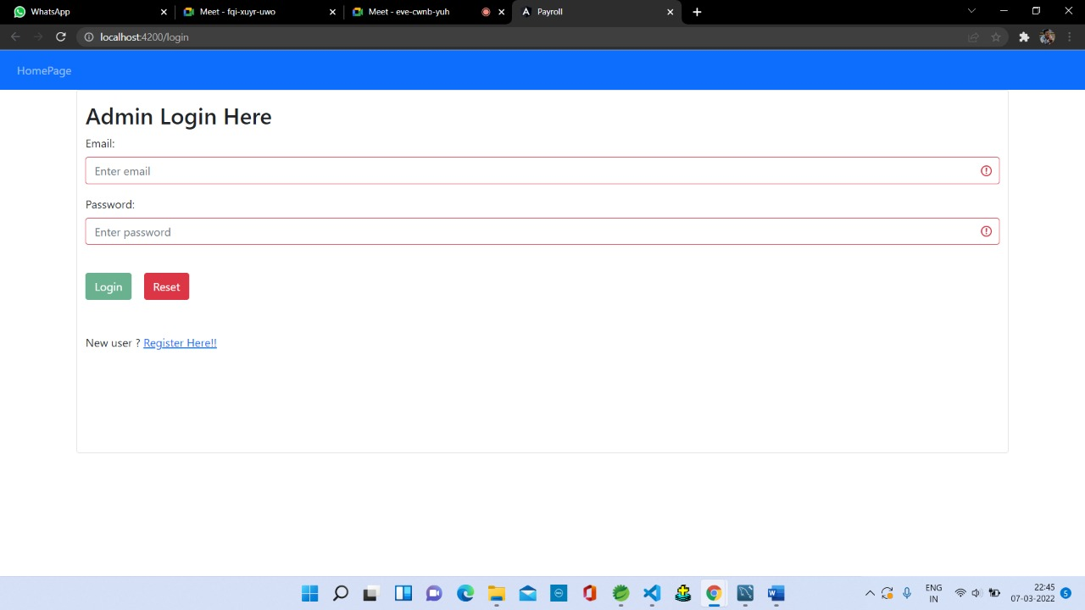

Employee list:
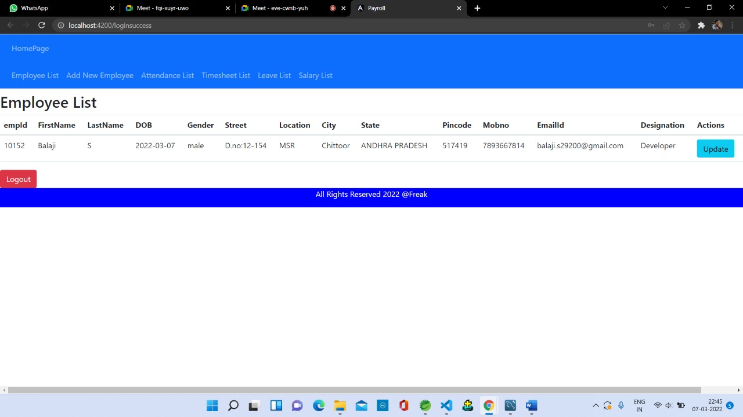

List of employee attendance:
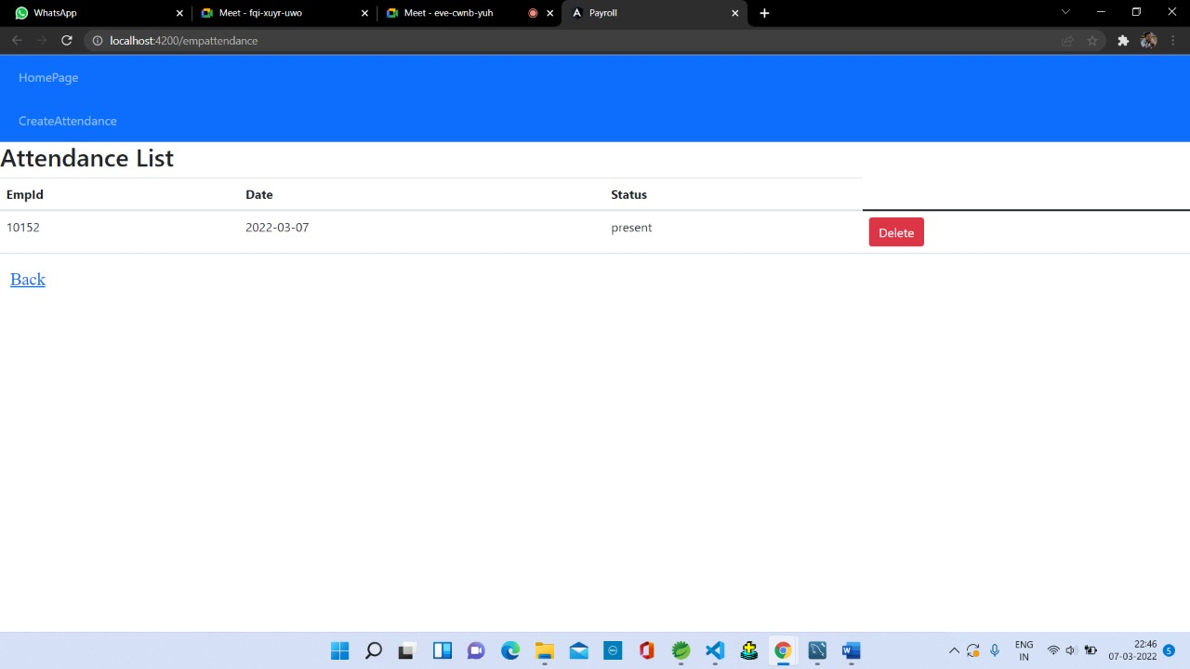

Employee profile & Pay Slip:
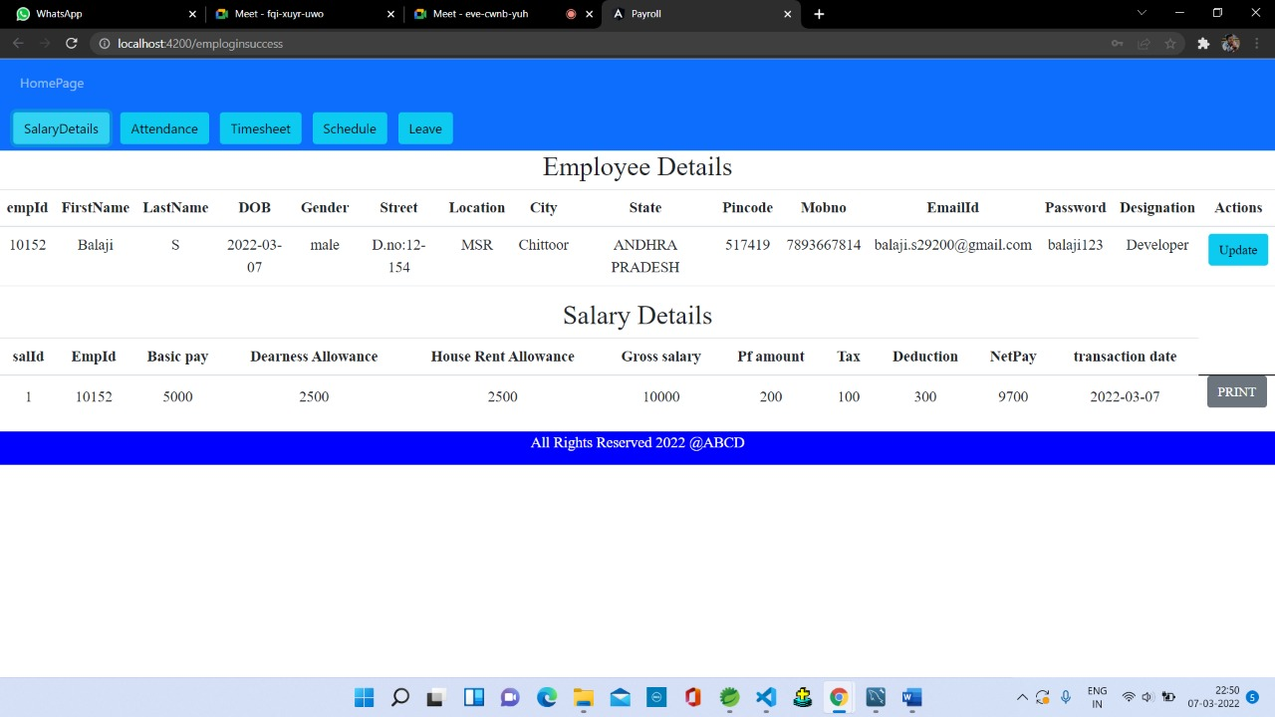

Timesheet List:
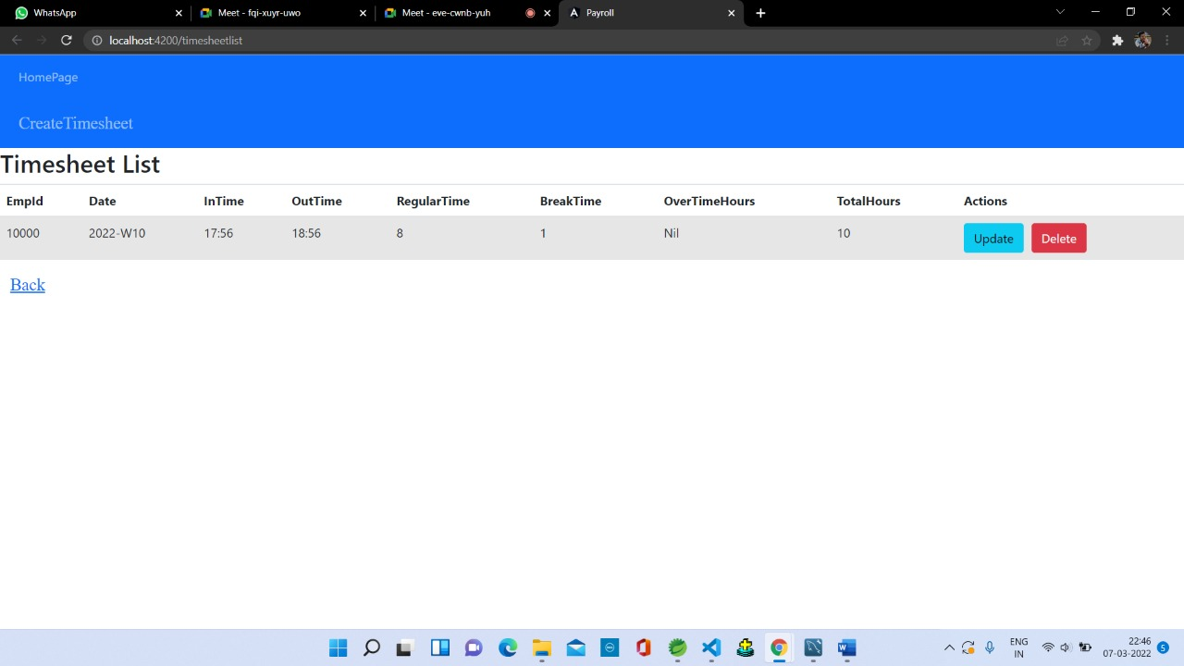

Leave List:
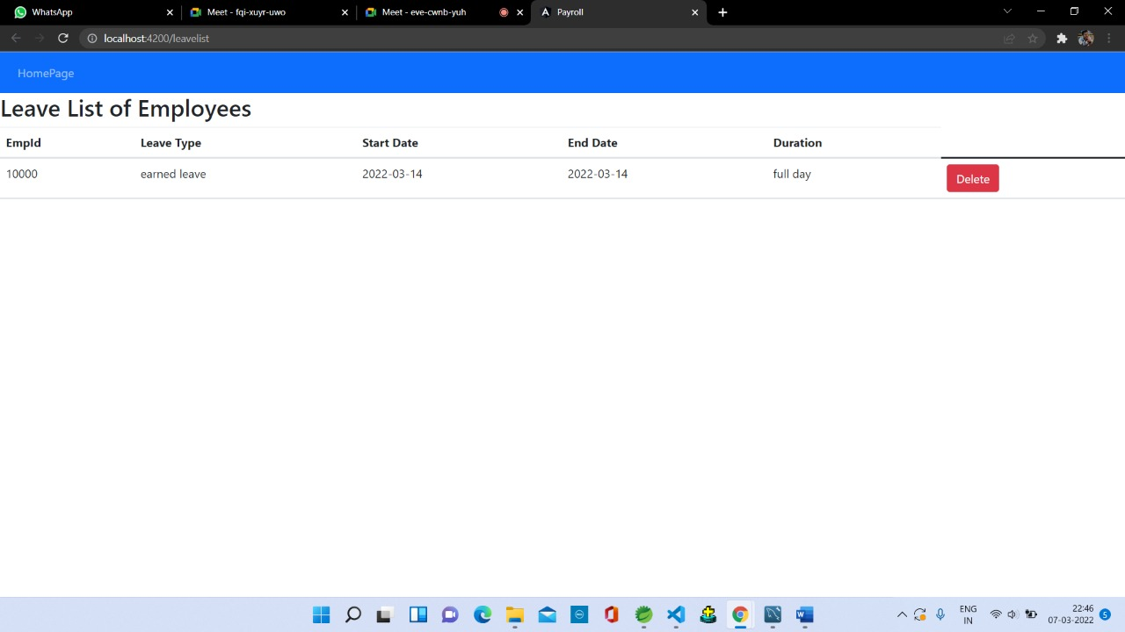

Conclusion:
This project is built keeping in mind that it is to use by admin and the employees in an organization. It is built for use in small scale organization where the number of employees is limited. According to the requested requirement the admin can add, manipulate, update and delete all employee data in his organization. The admin can add new Employee and delete them. The admin can also add predefined pay grades for the employees. The required records can be easily viewed by the admin anytime time he wants in an instant. The payment of the employee is based on monthly basis. Numerous validations implemented would enable the admin to enter accurate data. The main objective of this framework is to save time, make the system cost effective and management records efficiently.

